Goods receive (GR) posting process

- Once the SO is linked to the PO GR process begins.
- After receiving CMR based on report / tracker available
- Once CMR is received check if invoice available in VIM and compare: qty delivered and unit price
Transaction: /N/OPT/VIM_WP
Switch Work View: All Users View
Company code: 3701 (also can be checked without 3701)
Vendor: Supplier ID
And put Apply button and look for requested PO number
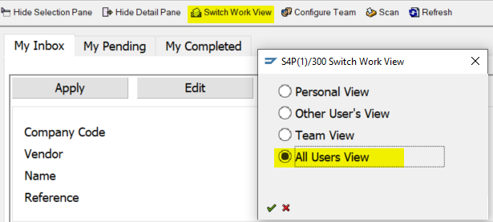

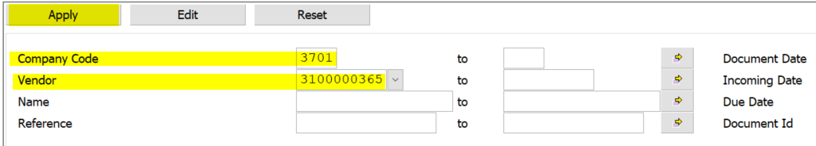
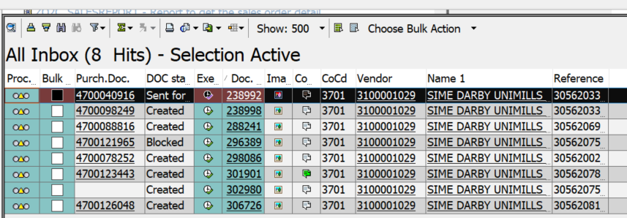
- Go to MIGO transaction / movement 101
Use following TAB details:
- Quantity – enter qty delivered
- Purchase order Data – Delivery completed Ind - change to “SET”
- Batch – Data of manufacturing - set to current date
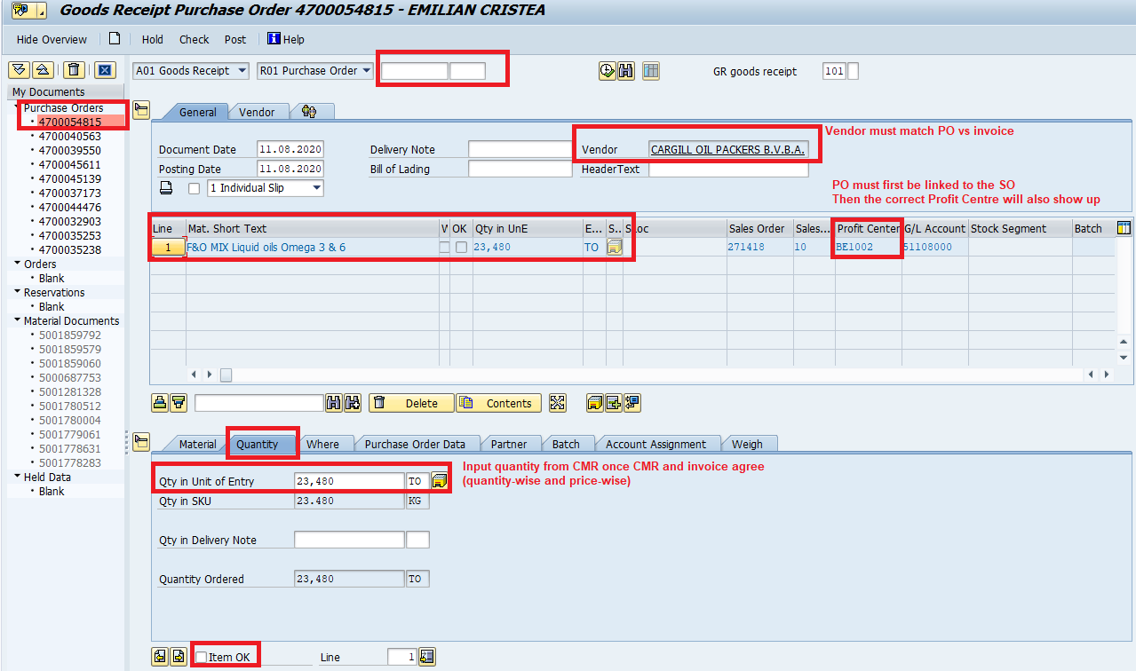
- Enter “check” to receive notification about batch creation and when documents is ok – “Post”

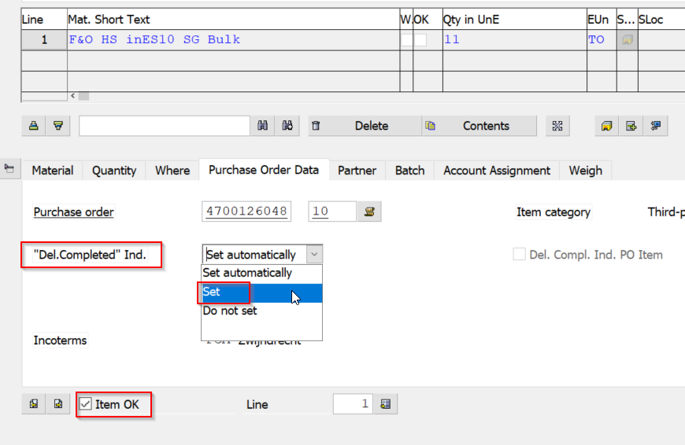

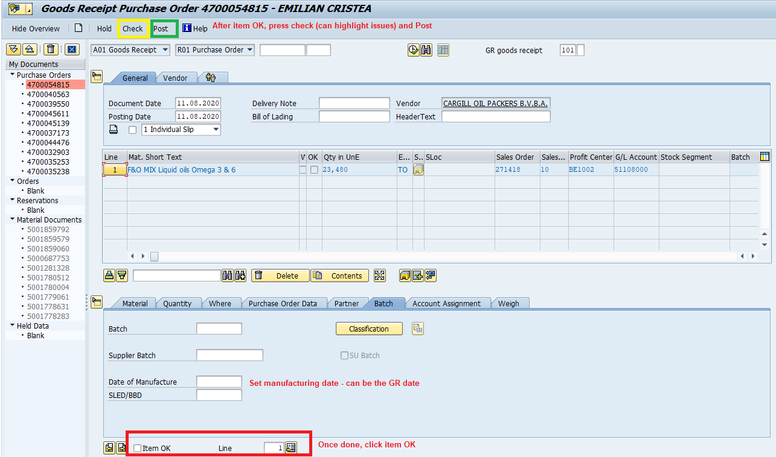
- If invoice is available in VIM task needs to be referred back to AP so that they can link the invoice to this GR’d PO
